Infractructure projects implemented by Daugavpils City Council in 2015

A work of project implementation, which started with financial planning period of 2007-2013 of European Union (EU), was completed in 2015. An active work took place at the next EU financial planning period and there was developed investment plan for the period 2014 – 2020 as well.
In financial planning period of 2007-2013 were implemented projects with amount of 193,5 million EUR: 142,5 million EUR or 73.6% of EU funding, 8,0 million EUR or 4,1% of state funding, 32,8 million EUR or 17% of municipal funding, and 10,2 million EUR or 5.3% of other sources of funding.

In 2015 there were completed important projects of urban infrastructure:

- „Reconstruction of Daugavpils City Transit Street A13”. Reconstruction of 18th November Street in Daugavpils City (stage of the Mēness Street to the city border).
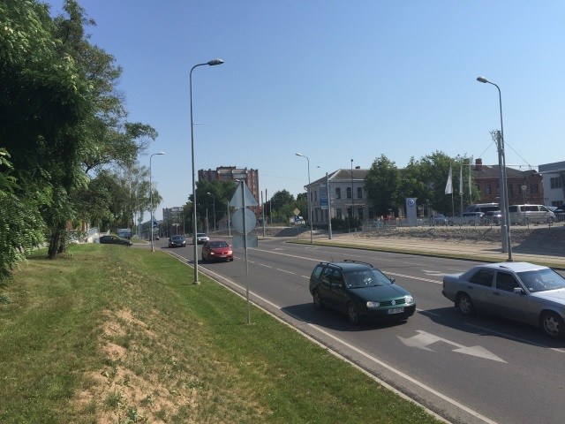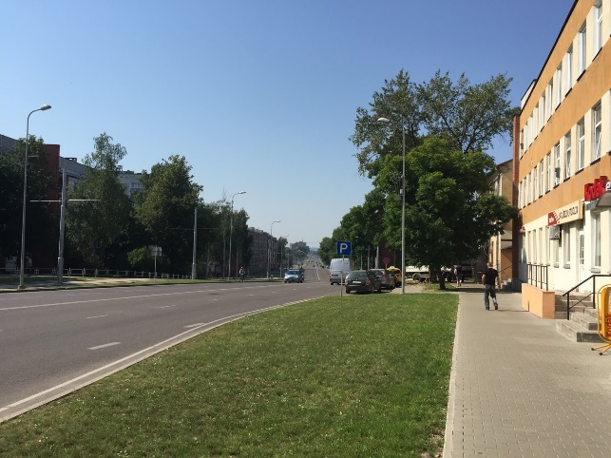
- „Reconstruction of Daugavas Street in Daugavpils City”. At one of the rotation circles there is built additional bar for entry into the city, as well as the supporting walls of Vienības (Unity) Bridge are fixed, which were in critical condition and became dangerous for the participants of traffic transport of Daugava Street.
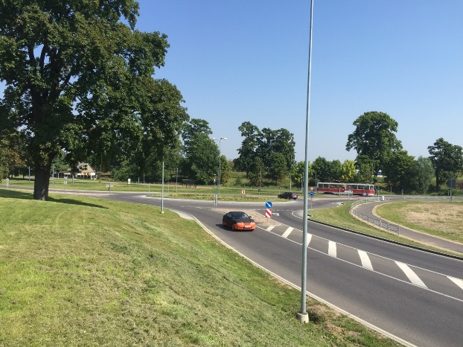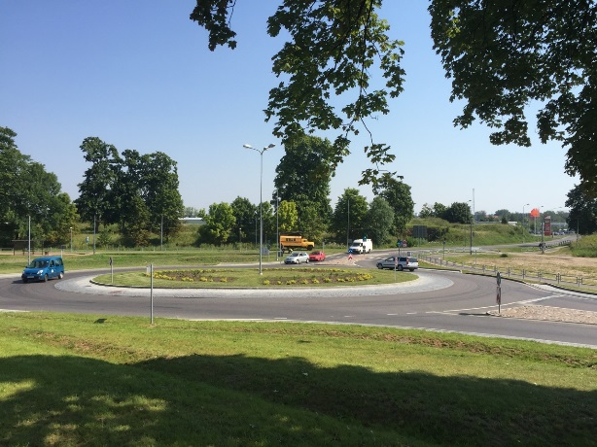
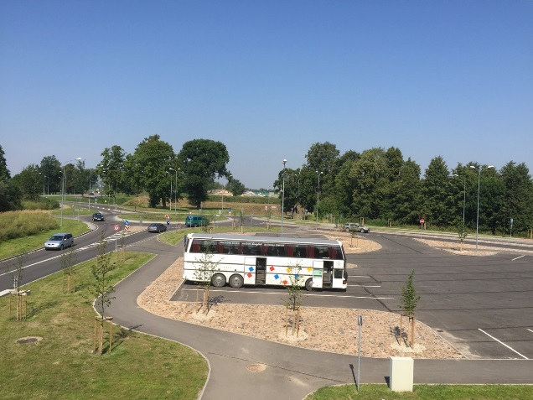
- „Transport Junction in Daugavpils City (Vidzemes, Piekrastes, A.Pumpura, Višķu Streets)”. Until the summer of 2015, strengthening works of road surface was carried out in Cēsu and Odu Streets.
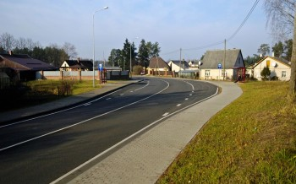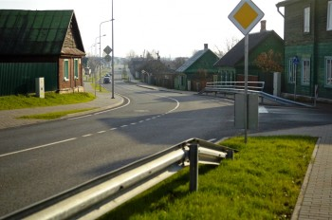
- „Renovation of Tram Infrastructure in Daugavpils City”. The project continued in 2015 and there was carried out reconstruction of tramway tracks and reconstruction of electric power in stations.
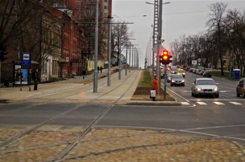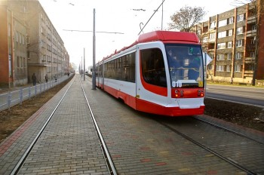
- “Infrastructure Development of Daugavpils Northern Industrial Zone”. There were carried out works of asphalt pavement laying within the project.
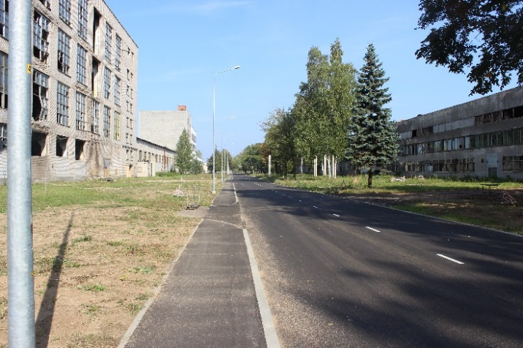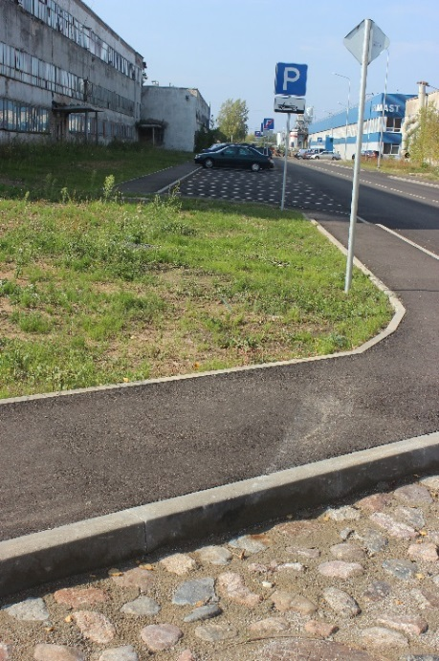
- „Tourism and Active Recreation Infrastructure Development in Daugavpils City”. There was completed a pedestrian / cycle path and the related infrastructure construction in Daugavpils City’s Stropi forest, thus, offering citizens opportunities for active recreation, leisure facilities in well-maintained environment in aim to promote a healthy and green lifestyle.
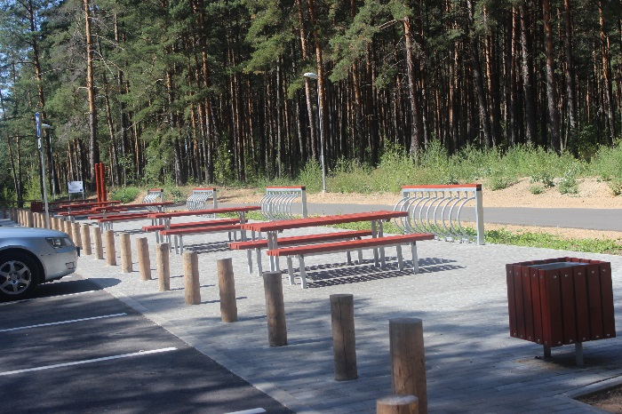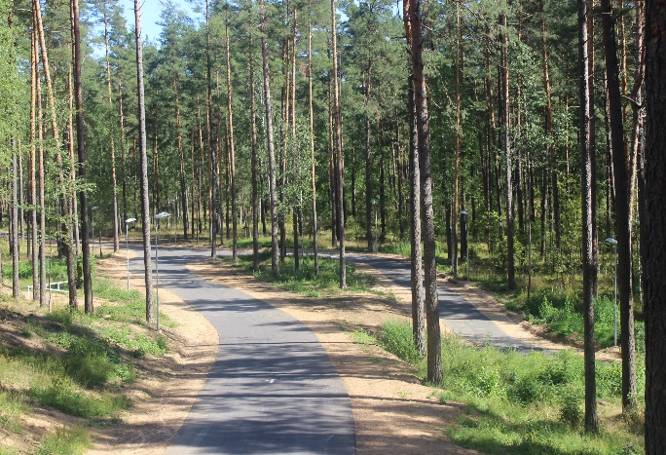
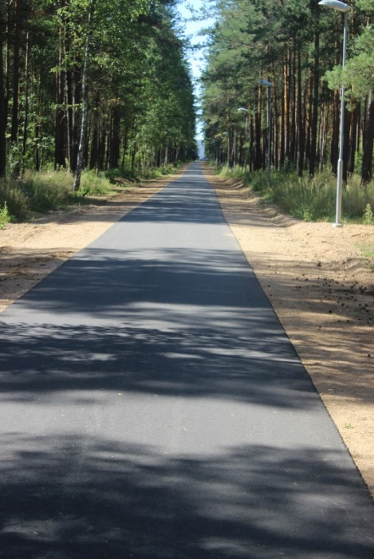
- "Increasing Energy Efficiency in the Buildings of Daugavpils Pre-School Education Institutions". In buildings of 20th and 22th pre-school education institutions were carried out insulation works of external walls, roof and floor of buildings, as well as installation of energy-efficient LED lamps.
In 2015 international project “Cultural and Historical Heritage Preservation and Promotion of Daugavpils City and Grodno City” was completed within the Latvia-Lithuania-Belarus cross-border cooperation program. Within the cooperation of Daugavpils and Grodno municipalities there were restored Daugavpils fortress lunette, as well, were organized cultural heritage workshops, trainings and artisan’s plenaries.

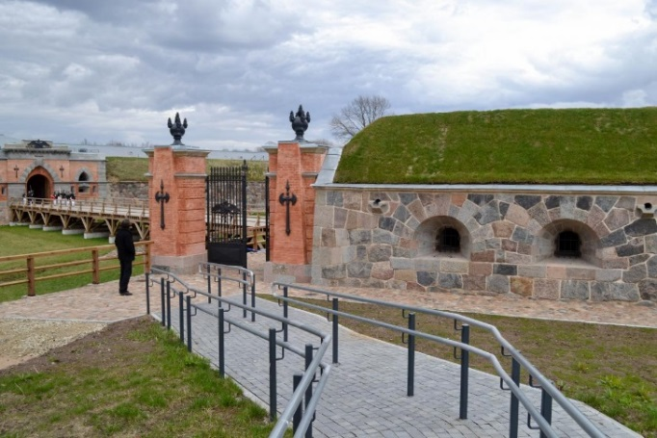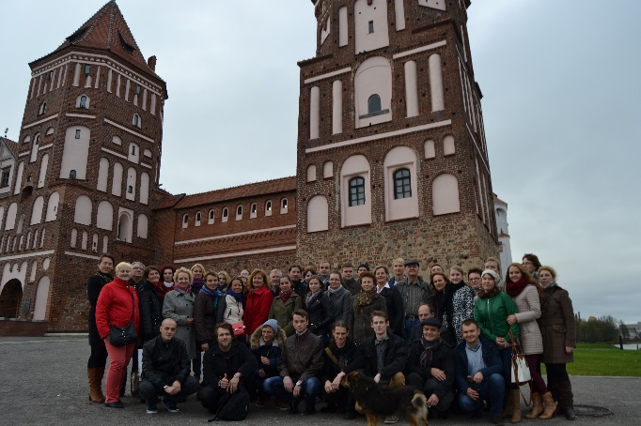

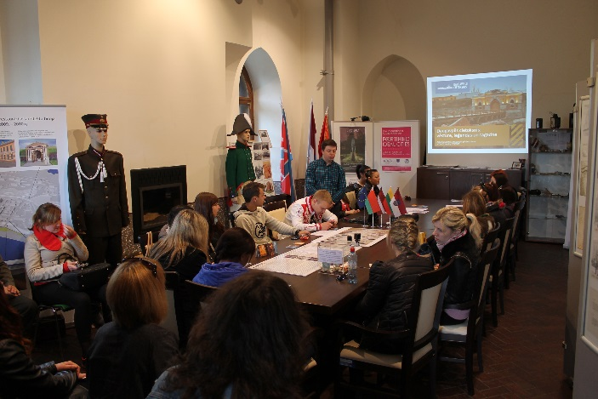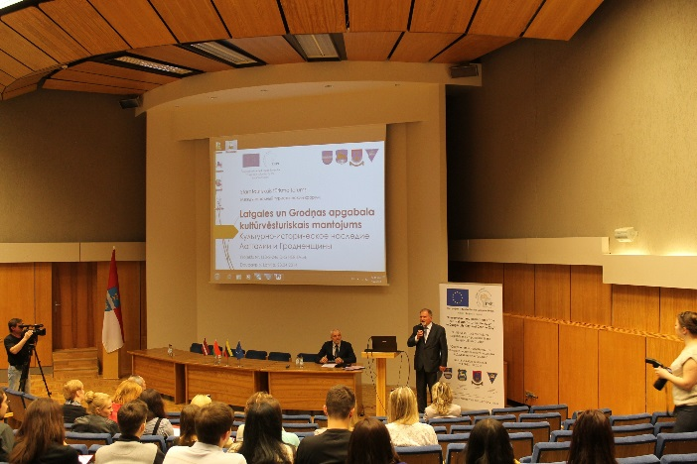

In 2015 started and successfully completed two CCFI projects “Energy-Efficient
Lighting Installation in J.Rainis Daugavpils 6th Secondary School and in Daugavpils 10th Secondary School Indoors” and “Greenhouse Gas Emission Reduction in Education Institutions of Daugavpils City Education Department” (Daugavpils 3rd Secondary School and Daugavpils 15th Secondary School), where were installed energy-efficient LED lamps.

In 2015 was launched ERDF project "Daugavpils City Council Capacity Increasing to
Ensure EU Funds Planning and Evaluation Process”. Within the project there will be carried out selection of project applications of EU financial planning period for 2014-2020.

Information prepared by: Development Department of Daugavpils City Council

