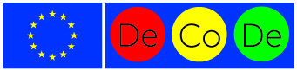
The first meeting of the project “Challenges of Regional Centres: Depopulation Control, Development – best practices” (DeCoDe) was held in Daugavpils
This year on May 23-24 Daugavpils City Council as the Lead Partner of DeCoDe project hosted partners from seven countries: Lithuania, Poland, Germany, Romania, Italy, Denmark and Spain. This was the first meeting of the project. The project is implemented within the framework of the 2nd strand "Democratic Engagement and Civic Participation" action 2.2 “Networks of Towns” of the European Union programme "Europe for Citizens". The project aims to create an international, sustainable network of European cities to share their experiences on depopulation processes and their impacts, and to find solutions to reduce depopulation.
The EU programme “Europe for Citizens” aims to bring Europe closer to its citizens by stimulating the debate on topical issues of the European Union at local, regional and international or member state level. To create conditions that enable citizens to participate in the European Union policy-making processes, to strengthen solidarity among European citizens, and to ensure that civil society organizations, their members and any member of society are involved in the democratic life of the European Union.
In Daugavpils, the project participants got acquainted with the essence of depopulation in the context of the world, European Union, Latvia and Latgale region, learned about the Latvian pilot project on remigration, shared experience about depopulation as a regional challenge, discussed the topicality of the project in the EU context, participated in the debates about the future of the EU, and got acquainted with Daugavpils during study visits. By implementing this project, the participating cities will promote international cooperation and sum up proposals for the control of depopulation, which will be available for the cities to use and integrate into their planning documents. The following invited experts and lecturers took part at the event: Agnese Lāce (PROVIDUS Leading Researcher in the field of migration and integration, involved in several national and international research projects), Varis Putniņš (Senior Specialist at the Regional Economics Division of the Department of Regional Policy of the Ministry of Environmental Protection and Regional Development), Astrīda Leščinska (Remigration Coordinator of Latgale Planning Region), Olga Ozola (SIA "IFT" Planning Specialist), Inga Goldberga (Executive Director of Daugavpils City Council). During the meeting participants also had the opportunity to take part in the concert of the Days of Slavic Culture and visit some of the Daugavpils tourism objects.
Within the framework of the project information on the depopulation situation of partners in their cities and countries will be gathered into a booklet, and work on publicity and dissemination of information to promote the project will be carried out. The next international meeting is planned in Kaunas, Lithuania this year in September.
The project is financed under the European Union programme “Europe for Citizens”. Implementation timeline: 01.03.2018.- 01.02.2020.
Information provided by the project coordinator J.Ūzuliņa
Jolanta.uzulina@daugavpils.lv
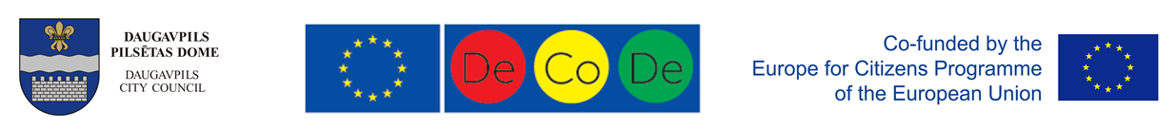
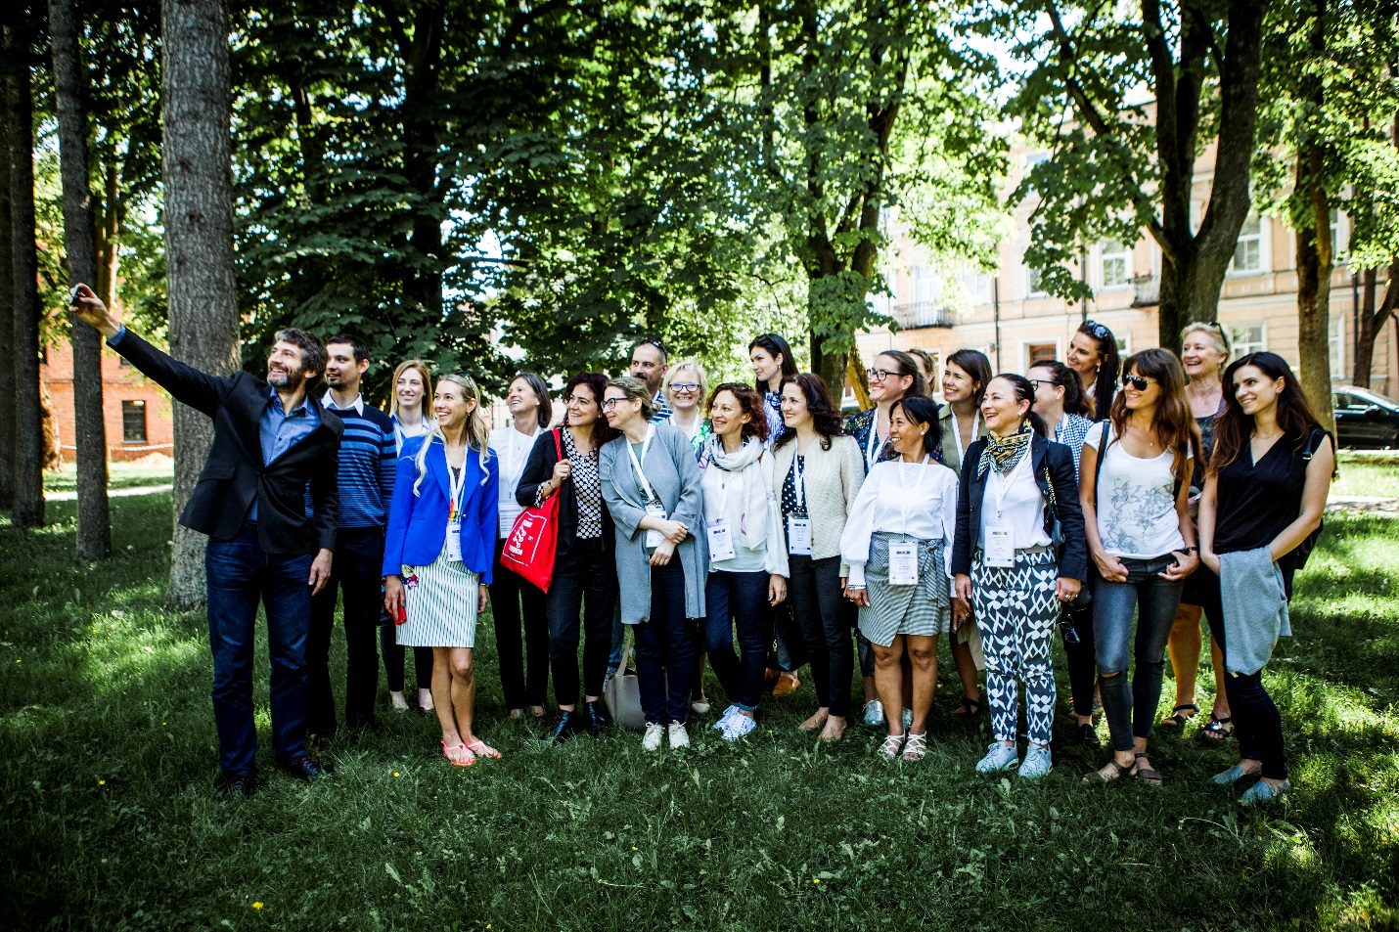
Project partners at Dubrovin Park

